**Empower The Nation App**

Splash Screen:

* Lasts for 3 seconds
* Used to check whether the user is logged in and which screen to go to next



Welcome Screen:

* Welcomes the user
* Button takes us to the login screen

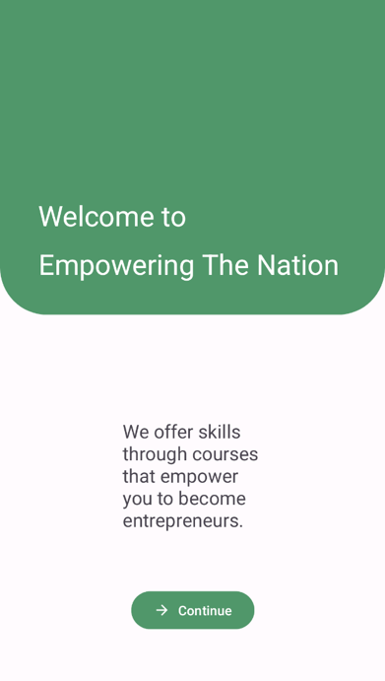

Login Screen:

* User enters login credentials
* Button for Forgotten Password and Create account taking the user to their own screens

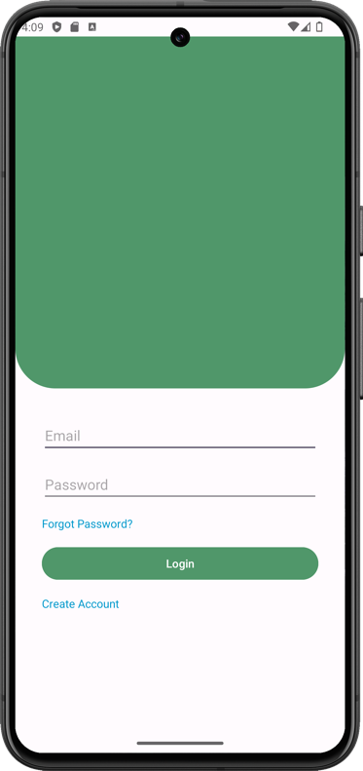

Forgot Password Screen:

* User enters their email and an email is sent with a link to change the password

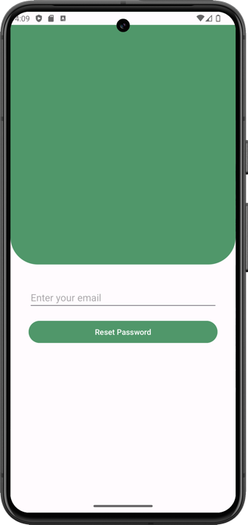

Create Account Screen:

* User enter their email and password

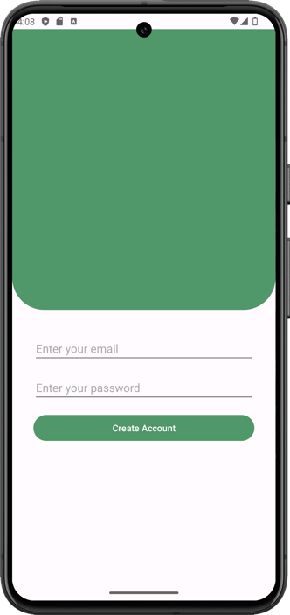

Home Screen:

* This is where the course’s purchased will appear

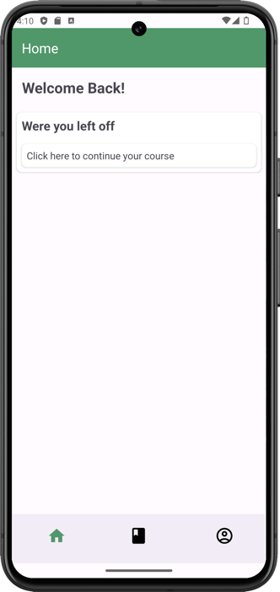

Courses Screen:

* A dropdown menu to switch between course types
* The user will click on a course and it will take them to that specific courses screen

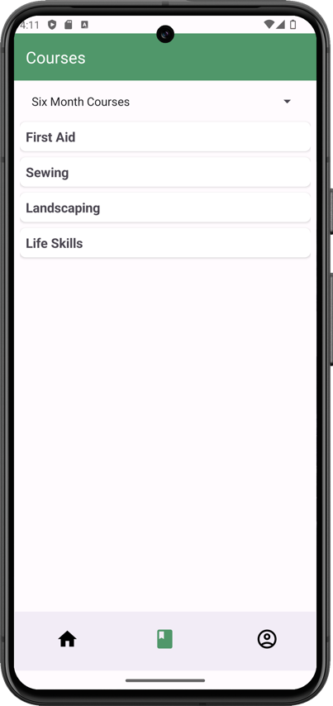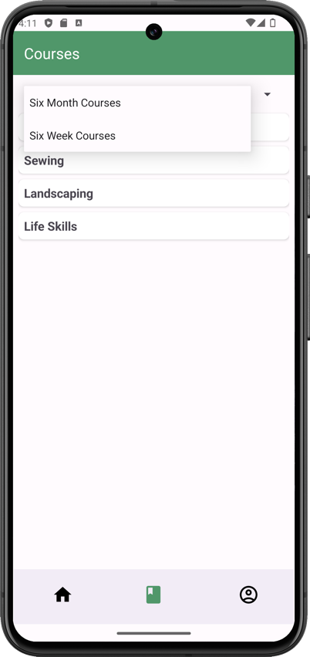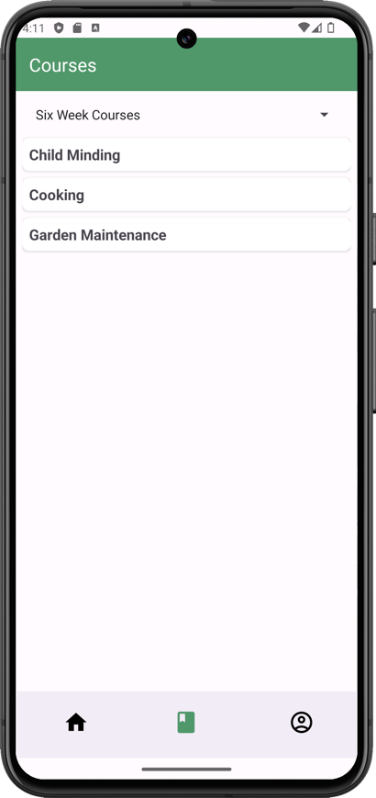

Courses:

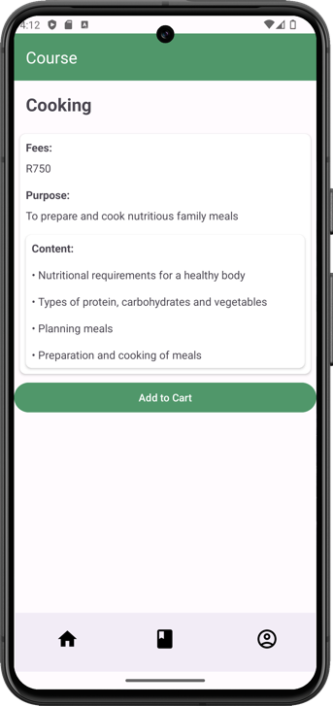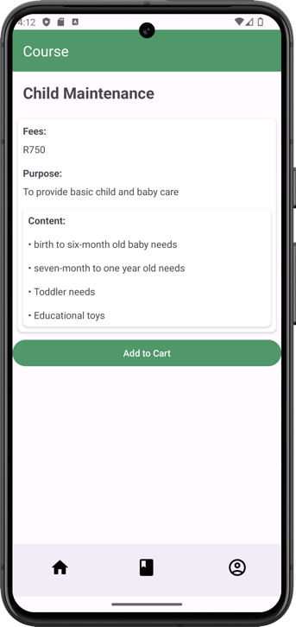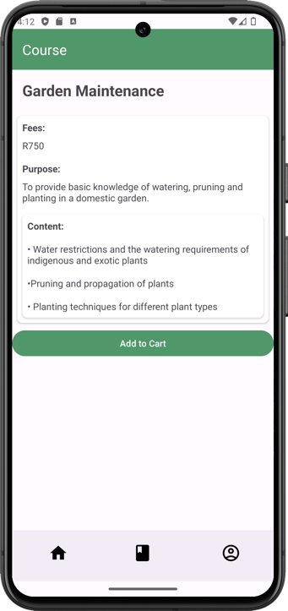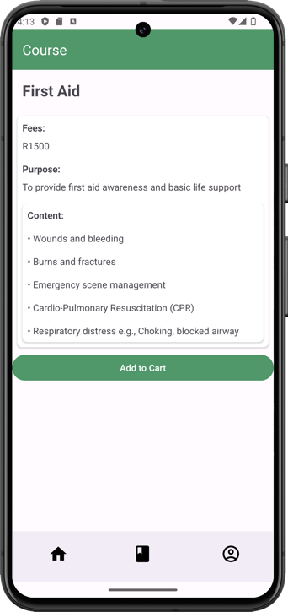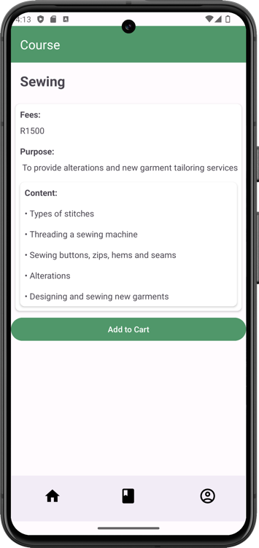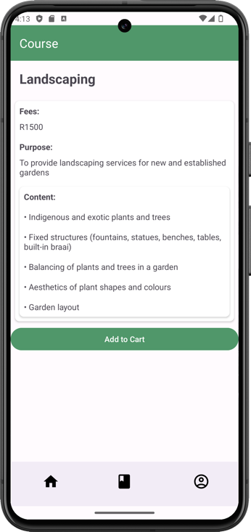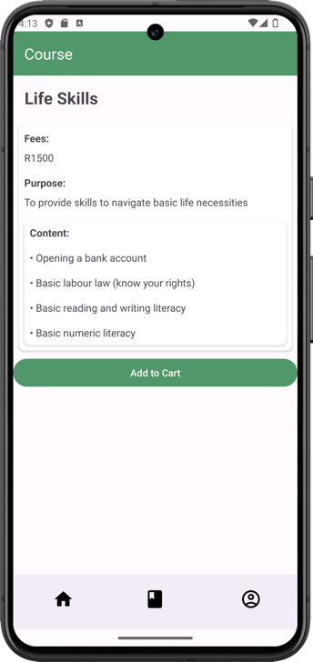

Account Screen:

* Has clickable cards that lead to individual screens

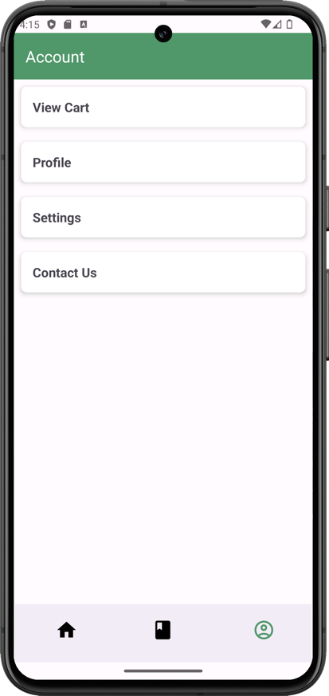

Profile:

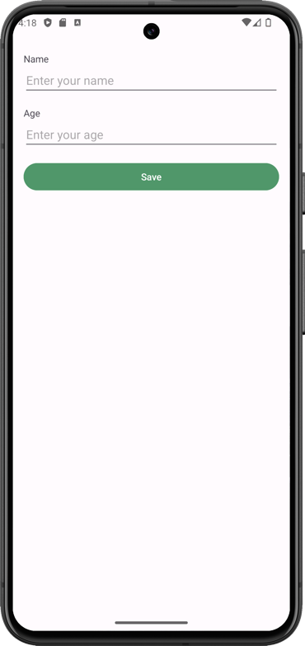

Settings:

* User can turn notifications on or off
* Change default language
* Turn on or off Dark Mode
* Log out button

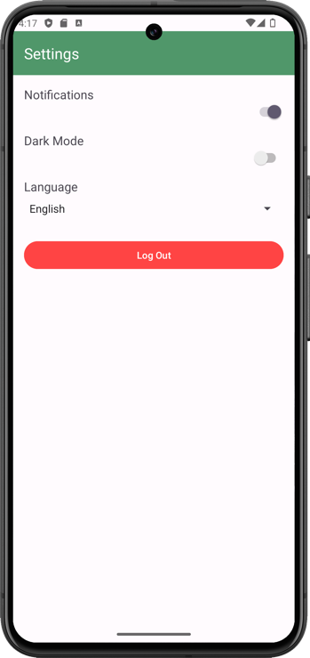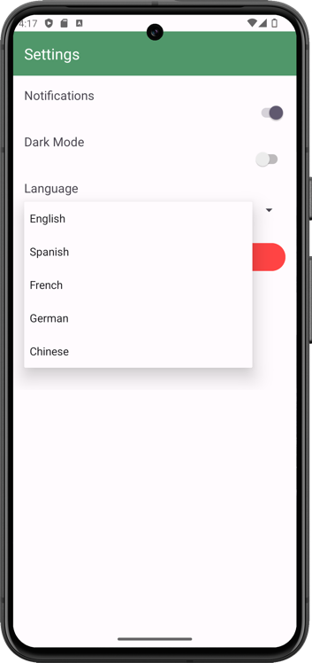

Contact Screen:

* Shows the email, number and address of the school
* Has each social media image that when clicked, takes the user to the website

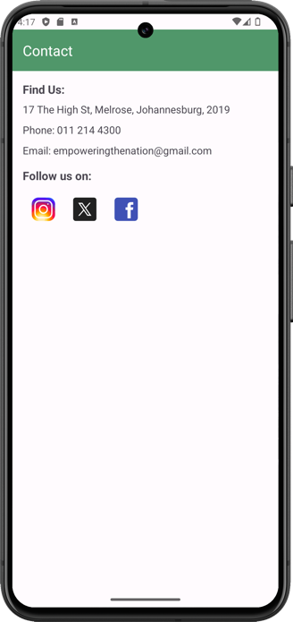

Cart:

* The course name and price are displayed with the price
* Discount and total price displayed
* A red ‘X’ to remove a course from the cart

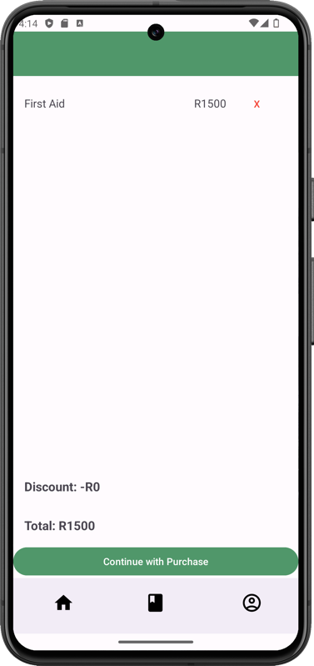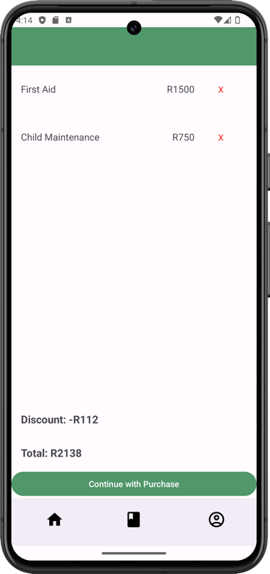

Payment Screen:

* Once the user has added items in their cart, they click on continue with payment taking the user to the payment screen
* User’s have option on a payment method

